Richland School Uniforms

What can be Worn at Richland as an approved School Uniform?

* Khaki, navy blue, or black, knee-length shorts, skirts, and jumpers (Jumpers have straps and collared shirt is worn underneath)- See Picture below.

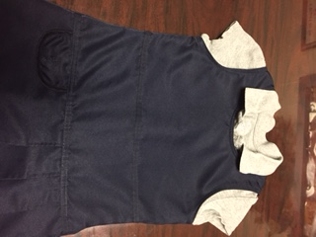 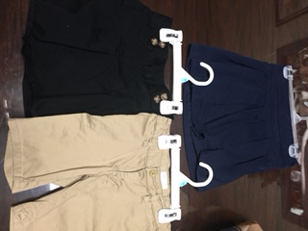

* Solid white, red, or light gray shirts or solid dresses (dresses must be shirt colors- red, white, or **light gray).** Turtle Necks are considered a collared shirt.

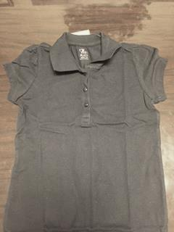 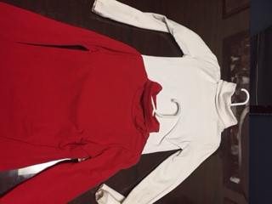 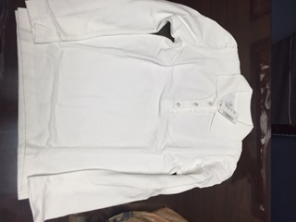 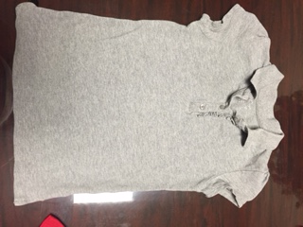

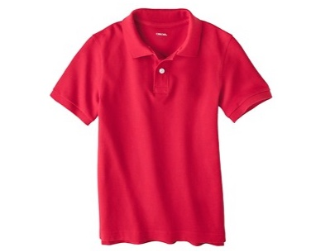 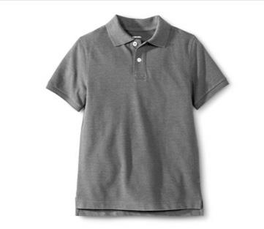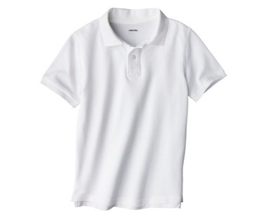

* White, red, or light gray spirit wear shirts- Shirts that have Richland written or embroidered on the shirts or dresses. (These do not have to a collar if they are Spirt wear.
* Solid tights or leggings in any uniform colors may be worn (red, white, gray, navy blue, black, or khaki) under the uniform. They may not be worn as the uniform pants.
* Solid navy blue, khaki, red, light gray or white sweaters or light jackets in the building (with or without Richland logo). Any type of heavy winter outer wear may be worn outside for recess.
* Shoes must have a strap around the heel.

What **cannot** be worn at Richland as part of the approved uniform?

* Navy blue, dark gray, or black shirts or dresses (dresses must be shirt color).
* Extremely loose or tight pants or tights/leggings worn as the pants.
* Green, yellow, pink, orange, or other non-approved colored jackets or sweaters
* College, professional team or store brand logos on shirts or jackets. (Only Richland Logos can be worn at school)
* Crocs

What is the difference between solid dresses and jumpers?

* Dresses are treated like the shirt and must be the shirt color (red, white, or light gray)
* Jumpers are treated as like pants and must be in the pant color (navy blue, black, or khaki) because a collared shirt is worn under them.



Jumpers have straps and a shirt is worn underneath. Jumpers must be one of the pant

colors (navy blue, black, or khaki)



Dresses are solid and with sleeves and must be one of the shirt colors (red, white, or light gray)